Score for this attempt: **4** out of 4

Submitted Oct 28 at 5:44pm

This attempt took 5 minutes.

**Question 1**

**1 / 1 pts**

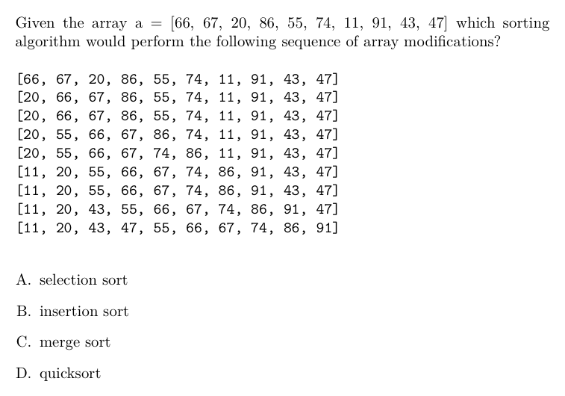



A

**Correct!**



B



C



D

**Question 2**

**1 / 1 pts**

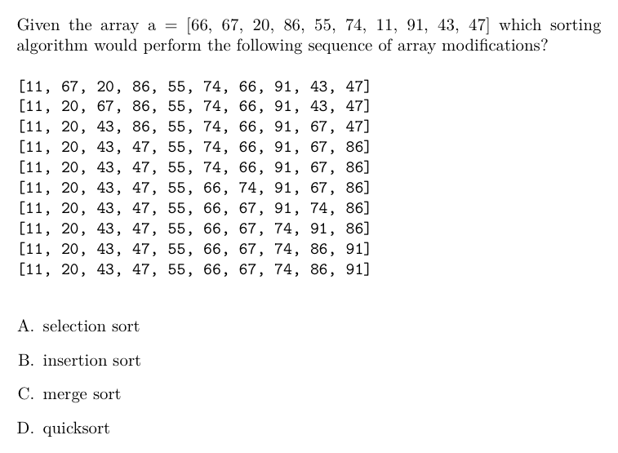

**Correct!**



A



B



C



D

**Question 3**

**1 / 1 pts**

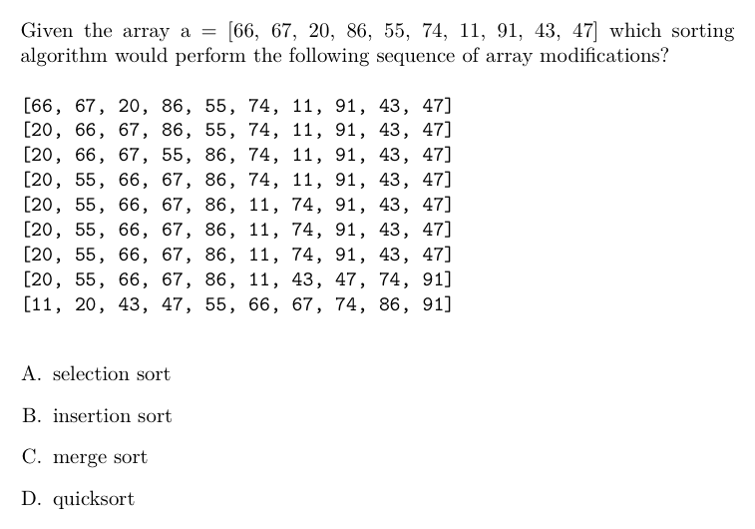



A



B

**Correct!**



C



D

**Question 4**

**1 / 1 pts**

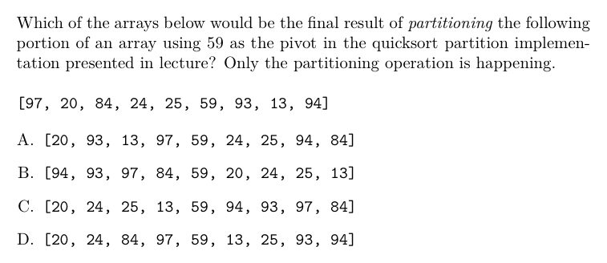



A



B

**Correct!**



C



D

Quiz Score: **4** out of 4